دولــــــــــــــــــة فلســـــــــــــــــطين

جامعة النـجـاح الـوطنـيـة

كليـة تكنولوجيا المعلومات

علم حاسوب

Palestine

An-Najah National University

Faculty of Information Technology

Computerized Information Systems



**Car maintenance management system(cmms)**

*Students:*

|  |  |
| --- | --- |
| Akram Assi | 11717123 |
| Moatadil Dweikat | 11716537 |
| Osama Odeh  Hamza Shakhsheer | 11527475  11717047 |

*Supervisor:*

Dr. Emad Saadeh

*A project report submitted in partial fulfillment of the requirements   
for B.Sc. degree in Computer Information Systems.*

*An-Najah National University*

*2020*

**Table of Contents**

Table of Contents ii

List of Figures iv

List of Tables v

Acknowledgement vi

Abstract ix

Chapter One

Introduction 1

1.1 Introduction 1

1.2 Project Scope 1

1.3 Problem Specification 1

1.4 Goals and Objectives 1

1.5Motivation 1

1.6 System Requirement 1

1.7 Project Plan and Schedule 1

1.8Outline of the Project 1

Chapter Two

Literature and Methodology 2

2.1Introduction 2

2.2 Current Systems*(Advantages, disadvantages, and weakness)* 2

2.3 Proposed System*(Advantages, disadvantages, and weakness)* 2

2.4 Feasibility Study 2

2.5Methodology*(for example: Agile, Waterfall, etc.)* 2

Chapter Three

System Analysis And Design 3

3.1System Analysis 3

3.1.1 Requirement Collection 3

*Examples of methods:*

3.1.1.1 Interview outline 3

3.1.1.2 System Service Request 3

3.1.1.3 Prototype 3

3.1.1.4 *Other Methods* 3

3.1.2 Requirement Studied 3

3.1.3 Requirement Structured 3

3.1.4 DFDs 3

3.2 System Design 3

*For Examples:*

3.2.1 Static Context Diagram 3

3.2.2 Use Case Diagram 3

3.2.3 Sequence Diagrams 3

3.2.4 Activity Diagrams 3

3.2.5 Scenarios 3

3.2.6 State Diagrams 3

3.2.7 Class Diagram 3

3.2.8 Database Schema (Mapping “Tables”) 3

Chapter Four:

System Implementation 4

4.1 Programming Languages 4

4.1.1 Why Using *(for Example: Java*) 4

4.1.2 Why Using *(for Example: SQL Server)* 4

4.2Implementation 4

4.2.1 Introduction 4

4.2.2Sample of Forms 4

4.2.3 Sample of Reports 4

4.2.4Pseudo Codes 4

Chapter Five:

System Testing 5

5.1 Testing Plans 5

5.2 Types and Steps of Testing 5

*For Examples:* (Unit testing, Integration testing, System testing, …)

Chapter Six:

The Conclusions 6

6.1Conclusion 6

6.2 Future Work 6

Appendix 7

A:System Installation 7

References 8

**List of Figures**

Figure 1: Title of the figure 1

Figure 2: Title of the figure 1

Figure 3: Title of the figure 1

Figure 4: Title of the figure 1

Figure 5: Title of the figure 1

Figure 6: Title of the figure 1

Figure 7: Title of the figure 1

Figure 8: Title of the figure 1

Figure 9: Title of the figure 1

Figure 10: Title of the figure 1

Figure 11: Title of the figure 1

Figure 12: Title of the figure 1

Figure 13: Title of the figure 1

Figure 14: Title of the figure 1

**List of Tables**

Table 1: Title of the table 1

Table 2: Title of the table 1

Table 3: Title of the table 1

Table 4: Title of the table 1

Table 5: Title of the table 1

Table 6: Title of the table 1

Table 7: Title of the table 1

Table 8: Title of the table 1

Table 9: Title of the table 1

Table 10: Title of the table 1

Table 11: Title of the table 1

Table 12: Title of the table 1

Table 13: Title of the table 1

Table 14: Title of the table 1

Abstract

CMMS is a web-based system designed to manage vehicle maintenance centers, which is a technology designed to help owners of a vehicle maintenance center who have difficulty organizing maintenance files for customers and thus reduce problems with customers and has an interface to customers that allows a customer to access their vehicle history and query and About the vehicle the condition of the vehicle, and the system will also provide the center owners with statistics to increase staff experience in the most frequently visited types of vehicles and replacement parts.

CMMS is designed to be easy for all users to use and convenient for users to use eye-friendly colors and to implement all the features in high resolution and designed to work on all devices with Internet connectivity [PC, Tablet, Mobile (iOS, Android)], The system provides the center with a wide range of services (manager (or center owner), expert (often engineer) and technician)

Chapter 1

1.1 Introduction

CMMS is a maintenance center management program that helps center owners in general and helps employees organize the well-focused vehicles and record all maintenance that has been performed, and the system will provide customers with access to the on-board maintenance log and an in-center status report via the Internet.

CMMS is a web application that can run during an Internet connection and CMMS has a simple, convenient interface for using

1.2Project Scope

CMMS is a module that is part of many systems of modules and will be integrated later with a comprehensive system and CMMS will provide a well-established center maintenance scheduling center and an inventory of parts within a center report on the most serviceable and customary vehicle types and will be available as well Provides a customer with a connection to a vehicle inquiry without a call at a center

1.3Problem Specification

In the maintenance center, many clients come to the place where most of the maintenance center is recording maintenance operations manually on paper or verbally, and this leads to the difficulty of knowing what operations were performed on a car accurately or knowing the parts that were changed and who did but rather the process and as the process Inquire about vehicles tired of a customer as he goes to the center

1.4 Goals and Objectives

* Providing center statistics to increase productivity
* Provide a record of maintenance operations
* Provide a record for both the customer and the vehicle
* Reducing problems between the customer and employees
* Managing and knowing the status of each vehicle inside a center

1.5 Motivation

The centers use maintenance in the Palestinian market, the manual method for registering each vehicle, or adopting the oral method in describing the problems, and this is difficult to know the problems precedent for each vehicle. It leads to a weakness in the person in the maintenance process and consequently the customer’s trust is lost. He should visit the center or call.

As this system will provide a way to organize maintenance records and the possibility of a customer arriving at a vehicle registry to know the condition of a vehicle inside a center (waiting, in maintenance, completed maintenance)

1.6System Requirement

1. Web server or Local server enabling:

a. wamp server

b.PHP

c. windows operating system & mac os .

2. editor: Microsoft Visual code and sublime.

3. mysql

5. Client side “PC or Mobile or Tablet” having browser.

6. html5, css3, ajax,jquery

Chapter Two

This chapter will provide information on the existing system in the car maintenance management system(cmms) and address the program proposed. We will assess the benefits and disadvantages of the proposed program. Finally the feasibility analysis and implementation approach for the proposed program will be described as a "graceful approach."

2.1 Introduction

Growing new system should have new technologies, certain advantages or have a fair and feasible solution to existing problems in the old systems. Within this chapter, we will describe the characteristics at cmms of both the current system and the new one. After reading this chapter the reader should be able to compare with full comprehension the old and new systems.

2.2 Current System

After visiting the garage in Nablus and looking at the system used in the garage, the result was as follows:

1- Manual( verbal ) :

It depends on the verbal use in dealing with customers in executing orders, while the faults of this system are more than the benefits.

The advantages of this method

* If the garage is small and contains fewer than two employees, this will be easier to manage and deal with customers.
* inexpensive.

The disadvantages for this method are:-

* Lack of customer confidence.
* Failure to manage the garage.
* Conflict description of the problem with the customer.
* Lack of a record to store the vehicle's maintenance operations.
* In the event of a defect in the previous maintenance process, it is difficult to describe the exact problem.
* Difficulty inquiring about the condition of the vehicle.

2- Computerized:

Depends on using systems to manage vehicle maintenance centers. Certainly better than the manual method.

Advantages of this method: -

● This system is part of a large system.

● Provide a system backup.

● Easy to use.

The disadvantages of this method are: -

* Inconsistency in colors and poor design
* High cost.
* Difficulty inquiring about the vehicle.
* Difficulty accessing the vehicle history.

2.3 Proposed System

There is nothing traditional in the cmms system, the technology has completely changed garage management. But the technology doesn't have to be complicated. The cmms system is easy to use and manage. From garage owners to serving employees, anyone can quickly become a "professional" with this system.

Now we will talk about the advantages of CMMs for each representative in garages and the use of the system starts from the manager to the customer:

1. The Manger:

The cmms system will enable the manager to access all operations in the garage, and add employees, and all user accounts will also be able to add parts and services provided by the garage and set prices and will also be able to view the statistics of the garage.

1. The expert:

He will be able to schedule maintenance operations that happen inside the garage, add customers to the system, make sure the vehicle is repaired and the vehicle is delivered to the customer, and is responsible for customer inquiries.

1. The Technical:

Responsible for maintenance operations, ordering parts from the expert and giving notes to the expert.

4-the Customer:

He will be able to access the history of the vehicle's maintenance operations, and know the condition of the vehicle inside the garage.

Although a new garage may seem costly for the initial cost of the cmms program, the investment is worth a try. The CMMS program provides several advantages which will increase customer trust and the efficiency of garages.

Advantages and disadvantages of the proposed software system: -

Both modern and advanced systems have advantages and difficulties in reaching the majority of the other systems, so there is tremendous demand for the system. As well as the drawbacks that can be minimized and regulated, so they can be ignored, regardless of their benefits.

* A table on the next page shows similarities  between the computerized system and the cmms system.

|  |  |  |
| --- | --- | --- |
| Comparison | cmms System | Computerized System |
| Inquire | On the way of application, he can know the status of the vehicle inside the center. | In order for the customer to inquire about the condition of the vehicle, he must come to the center or call him. |
| History | Through the application, the customer can access the record at any time and print it | The customer can only access the vehicle's record by visiting the center. |
| Design | Use comfortable designand uncomplicated. | Use clashing colors and uncomfortable. |
| Comfortable to use | Easy to use and understand from everyone. | Not everyone can understand and use it |

* The table highlights a distinction between the verbal system and the cmms.

|  |  |  |
| --- | --- | --- |
|  | cmms | verbal |
| history | Provides a history of all maintenance operations | It does not provide. |
| Inquire | On the way of application, he can know the status of the vehicle inside the center. | In order for the customer to inquire about the condition of the vehicle, he must come to the center or call him. |
| Customer confidence | high | low |
| organization of work | easy | hard |
| statistics | exist | not have |

The main benefits are summarized as follows:-

1. The cmms system contains records of maintenance operations, to gain access to all maintenance operations that were performed on the vehicle, and therefore in the event of a defect, the expert can review this record to know the nature of this problem.
2. The cmms system saves time and effort by helping workers inside the center to organize and finish the tasks assigned to them with efficiency and high speed compared to the oral system.
3. In terms of the use of harmonious colors and fitting to the nature of the garage, the cmms system gives you several choices to represent the nature of the garage and amazes the user, in addition to using a convenient and uncomplicated interface, unlike conventional systems and other programmes.
4. This system provides statistics to increase the productivity of the center, through knowing more vehicles that come to the garage to provide the necessary parts for them and increase the experience of employees.
5. This system provides a special platform for the customer to access his vehicle record and to know the status of his vehicle while it is in the garage.

The disadvantages are summarized as follows: -

In order to use it, the cmms program has to access the Internet so it can

deal with it. In the case of poor Internet connectivity, it can lead to slow calculation results.

2.4 Feasibility Study

1-Financial Feasibility

As a web application, CMMS will have a hosting cost associated with it. Since the system

Does not consist of any multimedia data transmission, the bandwidth required to play This app is very low.

The system will follow the standards of free software. No potential customers will be charged. Fixing errors and maintaining tasks will have a cost associated with them.

In the initial stage, the potential market area will be medium garages

Besides the associated cost, there will be many benefits to customers. Especially in the additional effort will be in remembering the details of the problem that has been fixed while efforts to create a record of each vehicle will be eliminated and also will be able to create statistical reports, since then from these results it is clear that the CMMS project is feasible in terms of winning the trust of the customers.

2-Technical Feasibility

Project CMMS is a complete web based application. The main technologies and tools that

are associated with CMMS are

* HTML5
* CSS3
* JAVASCRIPT
* PHP
* MYSQL
* EDITIOR USE
  + VISUAL STUDIO CODE
  + SUBLIME
* Diagram drawing tools
  + Microsoft Project
  + Visio

Each of the technologies are freely available and the technical skills required are manageable. Time limitations of the product development and the ease of implementing using these technologies are synchronized.

Initially the web site will be hosted in a free web hosting space, but for later implementations it will be hosted in a paid web hosting space with a sufficient bandwidth. Bandwidth required in this application is very low, since it doesn’t incorporate any multimedia aspect.

From these it’s clear that the project CMMS is technically feasible.

3- Resource and Time Feasibility

Resource feasibility:

Resource feasibility Resources that are required for the OES project includes,

* Programming device (Laptop)
* Hosting space (freely available)
* Programming tools (freely available)
* Programming individuals

So it’s clear that the project OES has the required resource feasibility.

4-Risk Feasibility

Risk feasibility can be discussed under several contexts.

Risk associated with size

Estimated size of the product in line of codes:

Being a web application with many number of customer, will

contain significant amount of code lines. the file sizes and the complete project size will not exceed 500MB.

Estimated size of product in number of programs:

Though the application supports many customer, it will be constructed as a single web application with a single login page rather than having many number of sites for different users. Depending on the access rights, the contents will be showed or hidden.

Size of database created or used by the product:

Database size will not exceed the values supported by MySQL (65526 entries per table). Number of relations and entities are minimized by using best practices of normalization theories.

1. Social/Legal Feasibility

CMMS uses the development tools available for free, and provides the system as a payment system

Maintenance cost will be calculated from potential customers.

2.5 Methodology

After in depth analysis of this program,  agile technique is selected for usage.

This applies to several factors, first of all the customer needs this program in a limited amount of  time and the agile succeeds in that, because. development is just a small part of the whole project,Additionally, the Agile approach tackles the unpredictable and evolving world (increasing demands, expectations, goals, technologies, etc.) by having the implementation team  in communication with the customer.

Ultimately, the Agile technique provides a cohesive collaboration atmosphere while they collaborate together to identify new approaches.

CHAPTER THREE

SYSTEM ANALYSIS AND DESIGN

3.1 Requirements discovery

Requirements discovery is the first activity in the requirements engineering life cycle, which is usually done by explaining the actors, units and requirements that are divided into functional and non-functional. It also develop requirements, collect requirements, analyze requirements and define requirements.

Consequently, this includes technical personnel working in vehicle repair to familiarize themselves with the scope of application, the services that the system must provide and the system's operational restrictions that may include end users, managers, engineers involved in maintenance and field experts.

3.1.1 Requirement Collection

Gathering requirements into information systems is an important part of the project. Any problems with provocative requirements will have an impact on the project as a whole. In some cases, the project may fail.This project proposes to present the process of gathering requirements by visit to several centers (Yaish, Fatayer, and Al-Bina), we concluded the requirements of the system by:

* interview: Ask the appropriate person (the owner of the center and its employees) about the requirements.
* Monitoring and reasoning: Monitor the behavior of users of the system and then deduce their needs from their behavior.
* Discussion and formulation: Discuss the needs of users and develop a common understanding of requirements.
* Negotiate regarding the set of criteria: Start with a standard list of requirements, and sdiscuss with users which of these requirements and functions will be required, required, or need to be modified.
* Study and identify problems. Investigate problems to identify them.

*3.1.2 Prototype*

Prototypes are an essential part of completing requirements in the system. This is done by building a small representative model of the basic requirements of the user, which helps us to clarify and complete the requirements and create new functions and discuss usability and prioritization.

3.1.3 Actors

The following are the main actors in the cmms system:

1-The Manger:

The cmms system will enable the manager to access all operations in the garage, and add employees, and all user accounts will also be able to add parts and services provided by the garage and set prices and will also be able to view the statistics of the garage.

2-The expert:

He will be able to schedule maintenance operations that happen inside the garage, add customers to the system, make sure the vehicle is repaired and the vehicle is delivered to the customer, and is responsible for customer inquiries.

3-The Technical:

Responsible for maintenance operations, ordering parts from the expert and giving notes to the expert.

4-the Customer:

He will be able to access the history of the vehicle's maintenance operations, and know the condition of the vehicle inside the garage.

3.2 Modules

* Records of maintenance operations:

Unit availability Records of maintenance operations Records of maintenance operations that occur for vehicles inside the center.

In specific, for each actor as the following:

1. The expert:

It sees and records the maintenance operations that happen to the vehicle inside the garage, and can search for and print a specific vehicle history, and He can see all the cars inside the center.

1. Technical:

Start and finish work on the vehicle, then send the notes to the expert.

1. Manger:

He sees a history of all maintenance operations within the center that you receive from the expert.

1. Customer:

He can access his vehicle history and see the status of his vehicle inside the garage.

* Garage parts (replacement part in garage)

1. the manger:

Add parts to the system and see their details.

1. The expert:

See details of the parts and their prices

* Management Modules

Just in the manger:

1. Add services to the system
2. Organizing staff work inside the system
3. see statistics based on maintenance information

3.3 Requirement

In this section, we will list all requirements from the two types which are nonfunctional requirements that describe how the system works, and functional requirements that describe what the system should do.

3.3.1 Functional requirement:

For the manger:

1. Add employee
2. Remove employee
3. Add customer
4. Add part
5. Add service(describe problem)
6. show all car in garage .
7. View all maintenance operation.
8. Show statistics.

For the The expert:

1. Add car to the system
2. Add New service
3. show part
4. Add New customer
5. show service
6. show all car in garage .

10-View all maintenance operation.

For The Technical:

1. Start Maintenance
2. end Maintenance
3. Send note
4. View his maintenance operations

For the customer:

1. See the status of his vehicle inside the garage.
2. View my car history.

3.3.2 Nonfunctional requirement:

* Usability:

1.The user friendly ui layout.

2.The program can be learned quickly.

3.The user will log in the system with any device (pc, phone, etc) using his\her assigned .

4.rapid move inside the system The system .

5.provides notification warnings to support the customer.

### Efficiency and Performance:

1. The system must deal with the maximum number of users without degradation of performance.
2. The system should be able to support a random number of devices.
3. The system provides quick service to the customer.

* Reliability:

1.Information is securely kept, so nobody has the right to delete it.

2.The system will ask the user to log in using a user name and user id.

* Security:

1. Information is securely kept, so nobody has the right to delete it.

2.The system will ask the user to log in using a user name and user id.

* Maintainability:

1. it can support any system from the web.
2. The system can be enhanced to run on different browsers (Google ,Mozilla Firefox, Google Chrome, safari).
3. we can add new features in easy way.
4. it easy to detect and diagnose the problem.

3.4Requirements specification

For the manager

1.

|  |  |
| --- | --- |
| function | Add employee |
| description | Add employee by the manger to the system, the user insert employee id and employee name Then he chooses his department)manger,expert,Technical). |
| input | employee id,employee name,department |
| Action | When the employee ID is entered into the system, the system checks it if it already exists, alerts the user that this employee already exists, if he does not add his name and specify his department. |
| Requires | Central database to storing employee |
| output | Display the new employee to the employee list. |
| Pre-condition | none |
| post-condition | none |
| Side-effects | none |

2.

|  |  |
| --- | --- |
| function | Remove employee |
| description | Select the employee to be removed |
| input | employee id |
| Action | The employee to be removed from the list is selected and then he presses the delete icon |
| Requires | Central database to storing employee |
| output | The page is refreshing |
| Pre-condition | This employee must be exist in the system |
| post-condition | His status becomes inactive and prevents him from entering the system again |
| Side-effects | none |

3.

|  |  |
| --- | --- |
| function | Add part |
| description | The manager adds the part to the system, where he enters the name of the piece, the brand of the parts, the count of parts and the name and phone number of the merchant. |
| input | part name,count of part , name merchant ,brand |
| Action | The manager enters the part's name and then the system checks these parts, if the parts are not already present on the system, it enters the brand, its number and the name of the merchant, if it exists, it increases the current number and enters the merchant's name and number. |
| Requires | Central database to storing parts |
| output | Display the list of parts |
| Pre-condition | None |
| post-condition | None |
| Side-effects | None |

4.

|  |  |
| --- | --- |
| function | Add service(describe problem) |
| description | The list contains most of the expected problems experienced by the expert with the cost of maintenance of each predefined. |
| input | Description problem , price |
| Action | Enter the service name and then its price |
| Requires | Central database to storing problems |
| output | Display the list of problems |
| Pre-condition | none |
| post-condition | none |
| Side-effects | none |

5.

|  |  |
| --- | --- |
| function | Car in center |
| description | Display information for all cars inside the garage |
| input | none |
| Action | Show cars available inside the garage after adding them by the expert. |
| Requires | Central database to storing information car |
| output | Show cars available inside the garage |
| Pre-condition | The expert must have previously added it to the system |
| post-condition | none |
| Side-effects | none |

6.

|  |  |
| --- | --- |
| function | History |
| description | Display all maintenance operations inside the garage made on all cars, enable the manager to search in a specific vehicle and can also view the record during a specific time period, and he can also print it |
| input | The date of the maintenance process,Plate number |
| Action | Displaying every history for the past six months, and if the manager wants a specific date that he enters with a search bar, he can access all maintenance operations on that date and if he wants to search for a specific vehicle he enters the vehicle number. |
| Requires | Central database to storing information about Maintenance operations |
| output | Display all history for the last six months, |
| Pre-condition | Maintenance work must have occurred in advance |
| post-condition | Display history . |
| Side-effects | none |

7.

|  |  |
| --- | --- |
| function | Add customer |
| description | Add customer to the system, the user insert customer id ,name, email , address and phone number . |
| input | id ,name, email , address and phone number . |
| Action | When the customer ID is entered into the system, the system verifies its existence and alerts the user to the existence of this customer already, if it is not present, he enters his name, email, address, and phone number |
| Requires | Central database to storing customers |
| output | Display the new customer to the customer list. |
| Pre-condition | None |
| post-condition | None |
| Side-effects | None |

8.

|  |  |
| --- | --- |
| function | statistics |
| description | Show all the stats for the five most garage customers, the top five brands of vehicles that come to the garage, the most commonly used parts inside the garage in general, and the most commonly used parts for a particular model of car in particular. |
| input | none |
| Action | It reads statistics from the database and then displays them |
| Requires | Central database |
| output | Display statistics |
| Pre-condition | Its information must be available within the database |
| post-condition | none |
| Side-effects | none |

For The expert:

1.

|  |  |
| --- | --- |
| function | Add car |
| description | It records the car information and added it to the system |
| input | Manufacturer, Model,name customer,vin,palte number,year,Fuel |
| Action | The user selects the owner of the vehicle and enters the vehicle data (Manufacturer, Model, name customer, vin, palte number, year, Fuel) into the system. |
| Requires | Central database |
| output | none |
| Pre-condition | The vehicle owner must be present in the database |
| post-condition | The vehicle appears in the customer's list of vehicles |
| Side-effects | none |

2.

|  |  |
| --- | --- |
| function | New service |
| description | It takes the description of the problem from the customer and then identifies the problem and the parts used. |
| input | Describe the problem from customer ,palte no,last kilometer,Description of the problem from the expert and the parts used |
| Action | The description is taken from the customer, then the expert enters the meter reading to calculate the age of the parts that are replaced periodically, then he determines the problems and the required parts. |
| Requires | Central database |
| output | Vehicle information appears in the list of cars inside the garage |
| Pre-condition | The customer and the vehicle must be inside the system |
| post-condition | none |
| Side-effects | The vehicle information appears at the manager and the technician, and the customer's condition (waiting). |

3.

|  |  |
| --- | --- |
| function | show part |
| description | It displays the previously added parts by the manager |
| input | none |
| Action | It takes part information inside the database |
| Requires | Central database |
| output | Display the list of parts |
| Pre-condition | Parts must already be inside the database |
| post-condition | none |
| Side-effects | none |

4.

|  |  |
| --- | --- |
| function | Add customer |
| description | Add customer to the system, the user insert customer id ,name, email , address and phone number . |
| input | id ,name, email , address and phone number . |
| Action | When the customer ID is entered into the system, the system verifies its existence and alerts the user to the existence of this customer already, if it is not present, he enters his name, email, address, and phone number |
| Requires | Central database to storing customers |
| output | Display the new customer to the customer list. |
| Pre-condition | None |
| post-condition | None |
| Side-effects | None |

5.

|  |  |
| --- | --- |
| function | show service |
| description | It displays the previously added problem by the manager and the price. |
| input | none |
| Action | It takes problem information inside the database |
| Requires | Central database |
| output | Display the list of problem |
| Pre-condition | Problem must already be inside the database |
| post-condition | none |
| Side-effects | none |

6.

|  |  |
| --- | --- |
| function | History |
| description | Display all maintenance operations inside the garage made on all cars, enable the expert to search in a specific vehicle and can also view the record during a specific time period, and he can also print it |
| input | The date of the maintenance process,Plate number |
| Action | Displaying every history for the past six months, and if the expert wants a specific date that he enters with a search bar, he can access all maintenance operations on that date and if he wants to search for a specific vehicle he enters the vehicle number. |
| Requires | Central database to storing information about Maintenance operations |
| output | Display all history for the last six months, |
| Pre-condition | Maintenance work must have occurred in advance |
| post-condition | Display history . |
| Side-effects | none |

7.

|  |  |
| --- | --- |
| function | Car in center |
| description | Display information for all cars inside the garage, and see the notes provided by the technician in case of other problems |
| input | none |
| Action | Show cars available inside the garage |
| Requires | Central database to storing information car |
| output | Show cars available inside the garage |
| Pre-condition | must have previously added the car to the system |
| post-condition | none |
| Side-effects | none |

For the Technical:

1.

|  |  |
| --- | --- |
| function | Start Maintenance |
| description | Starting the maintenance process on the vehicle |
| input | none |
| Action | Starting the maintenance process on the vehicle and changing its status from waiting to maintenance. |
| Requires | Central database |
| output | none |
| Pre-condition | The expert must have previously added it to the system |
| post-condition | none |
| Side-effects | The status of the vehicle changes from waiting to maintenance in the vehicle record inside the center with the manager and the expert, and its status with the customer changes from waiting to maintenance |

2.

|  |  |
| --- | --- |
| function | End Maintenance |
| description | Starting the maintenance process on the vehicle |
| input | none |
| Action | Ending the maintenance process on the vehicle and changing its status from maintenance to finish.. |
| Requires | Central database |
| output | none |
| Pre-condition | The expert must have previously added it to the system |
| post-condition | none |
| Side-effects | The status of the vehicle changes from waiting to maintenance in the vehicle record inside the center with the manager and the expert, and its status with the customer changes its status from maintenance to finish.. |

3.

|  |  |
| --- | --- |
| function | Send note |
| description | Send notes to the expert in the event of another problem |
| input | Note |
| Action | If the vehicle is pressed, a window appears to send its note, and the notes are sent directly to the expert |
| Requires | Central database |
| output | none |
| Pre-condition | The vehicle must be registered by the expert, and work must be done on it now |
| post-condition | none |
| Side-effects | A note appears to the expert about the maintenance status |

4.

|  |  |
| --- | --- |
| function | My work |
| description | Disaplay the history of the cars that he worked on beforehand |
| input | none |
| Action | He retrieves the vehicle registry from the database on which he worked |
| Requires | Central database |
| output | Disaplay the history of the car |
| Pre-condition | The vehicle must be finished |
| post-condition | none |
| Side-effects | none |

For The customer:

1.

|  |  |
| --- | --- |
| function | View status |
| description | Display the vehicle’s status inside the center, whether it is waiting or servicing, or work has ended on it |
| input | Note |
| Action | Take information about the vehicle’s status from the database, if the vehicle is located inside the center, and it displays it if it does not |
| Requires | Central database |
| output | Display the vehicle’s status |
| Pre-condition | The vehicle must be exist in the center |
| post-condition | none |
| Side-effects | none |

2.

|  |  |
| --- | --- |
| function | View my car history |
| description | Display all maintenance operations inside the garage made on all cars, enable the manager to search in a specific vehicle and can also view the record during a specific time period, and he can also print it |
| input | The date of the maintenance process |
| Action | Display all history , and if the manager wants a specific date, he can reach it |
| Requires | Central database |
| output | Display all history |
| Pre-condition | Maintenance work must have occurred in advance |
| post-condition | none |
| Side-effects | none |

3.5 Requirements prioritization and negotiation .

Likelihood of Success – Similar to difficulty of implementation, this method is frequently employed when a project is divisive and needs to shore up stakeholder support. It places highest priority on requirements with a high probability of success.

Stakeholder Agreement – With this approach, stakeholders must come to a consensus on which requirements are most important, and then those are given highest priority. Within most organizations, stakeholder agreement is likely to be at least a partial factor no matter what other prioritization methods are employed.

Relationship to Other Requirements – Requirements often intermingle in complex relationships of interdependence. With this approach, requirements that support other high-priority requirements are also given high priority.

3.6 Requirements validation

We did this:

* Group Session: we have been organizing meeting sessions with the stakeholders and have come to an agreement on the needs which resulted in the current state of the system requirements.
* Perspective-based reading: each single use case is reviewed independently by all team members.

3.7 Requirements management:

'CMMS' has been built using the Agile approach, and any adjustment of specifications has three options, first, specifications shift before implementation has been built, in which situation no design is required so it is simple to modify them, second requirements adjustment through creation and after implementation of the package,in this case the whole module should be change according to what actors asking for.

3.8 System Design

3.8.1 Static Context Diagram

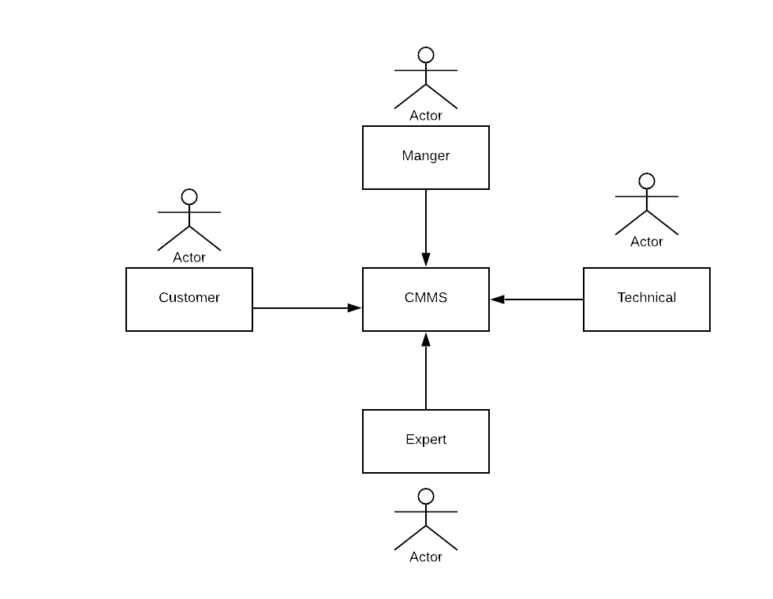

3.8.2 Use Case Diagram

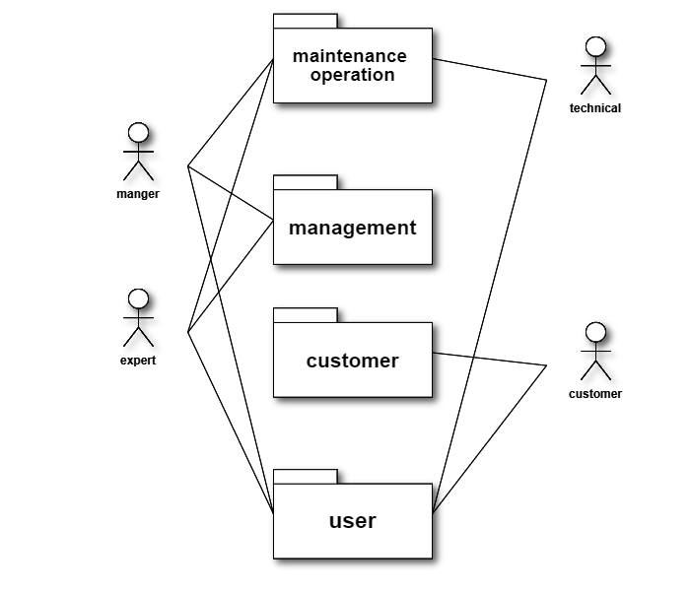

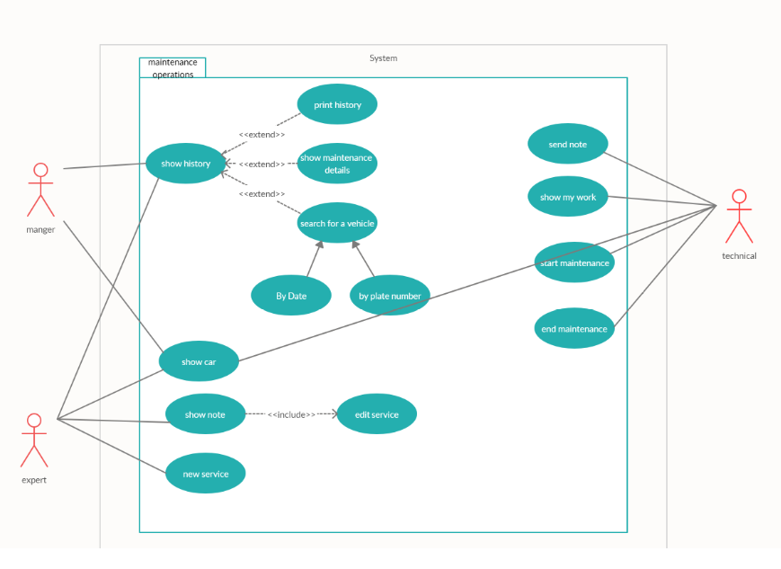

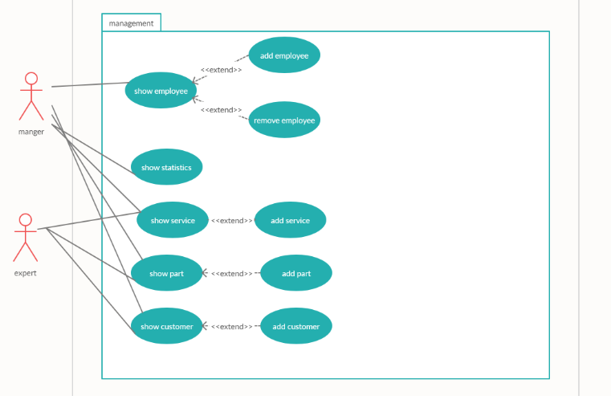

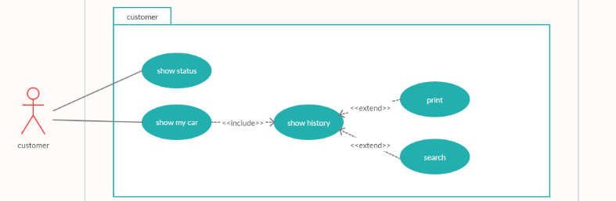

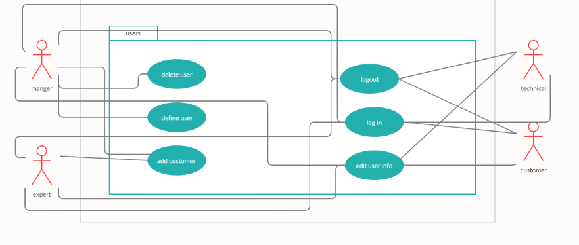

3.8.3 Sequence diagrams:

1. New service

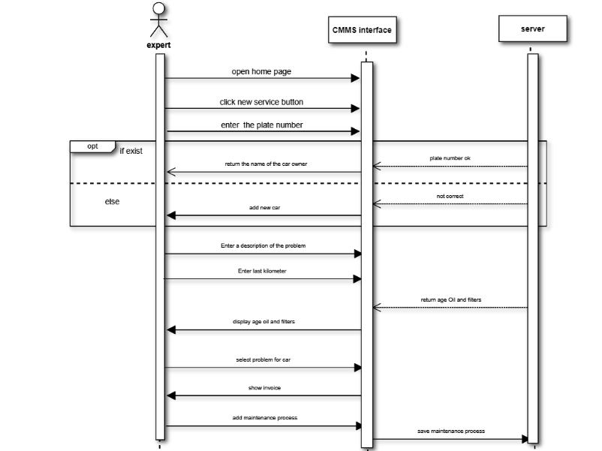

1. add part

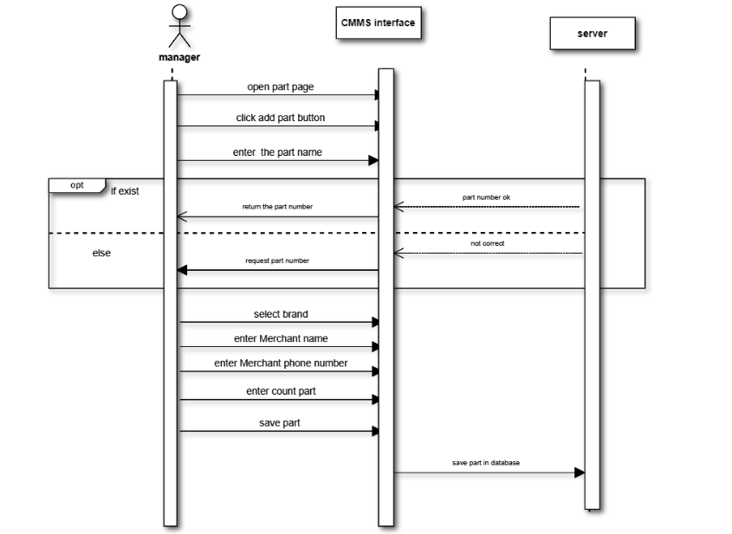

1. Add employee

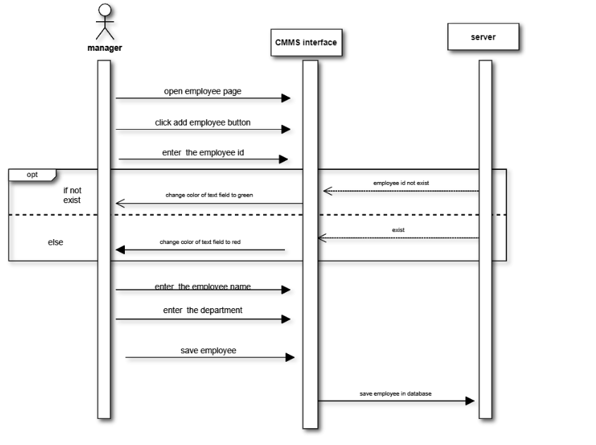

1. Remove employee

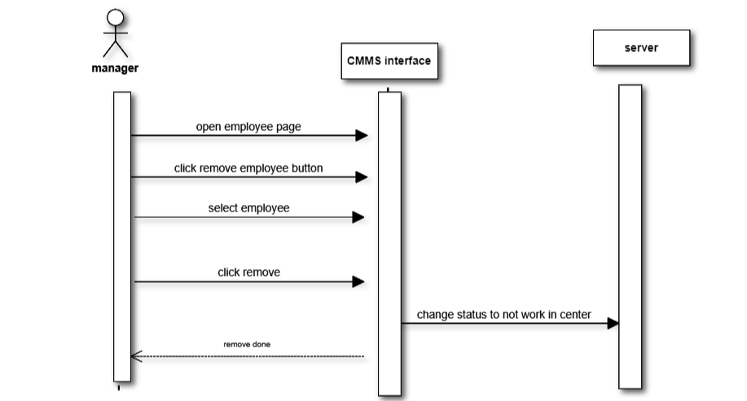

1. Show status

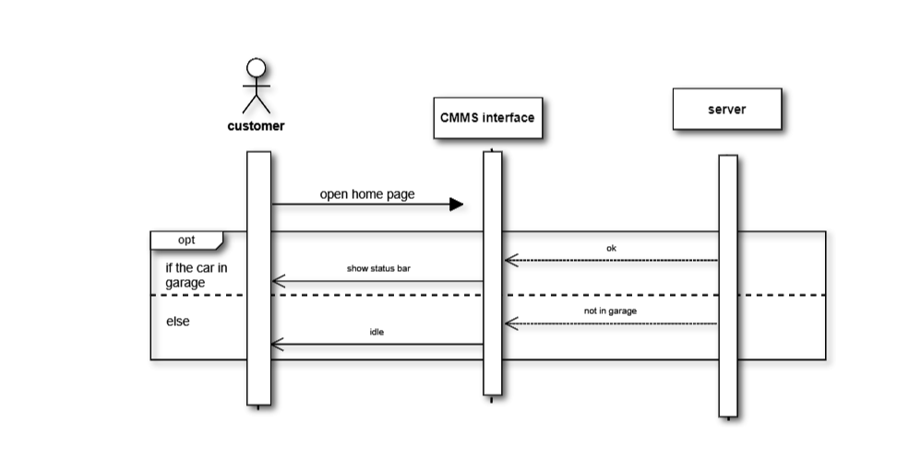

3.8.4 Activity diagrams :

1. New service

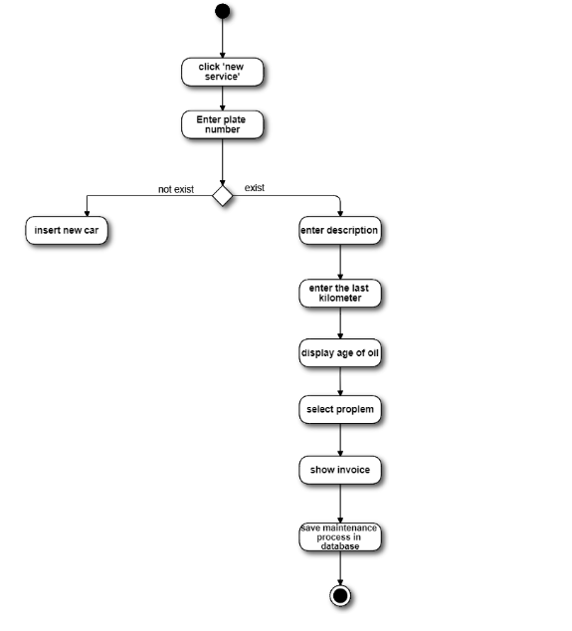

1. Add part

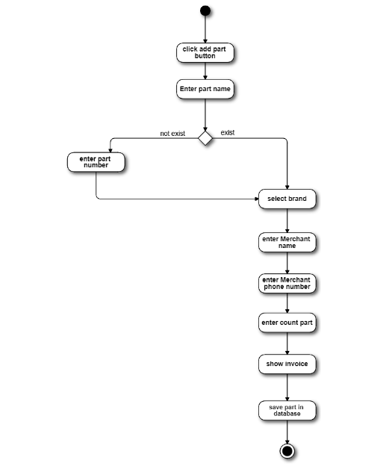

1. Add employee

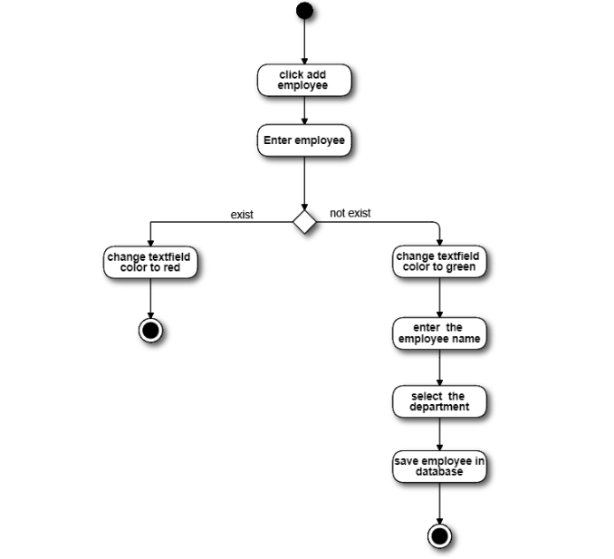

1. Remove employee

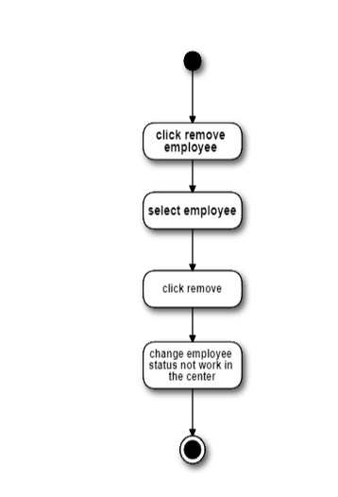

1. show status

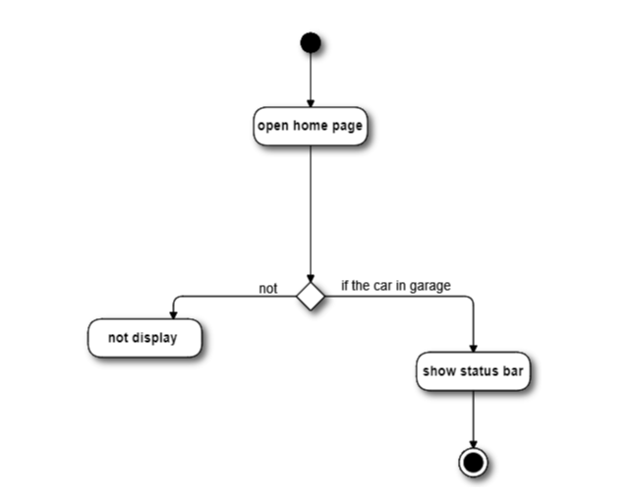

3.9Class diagram  and ER

Class diagram

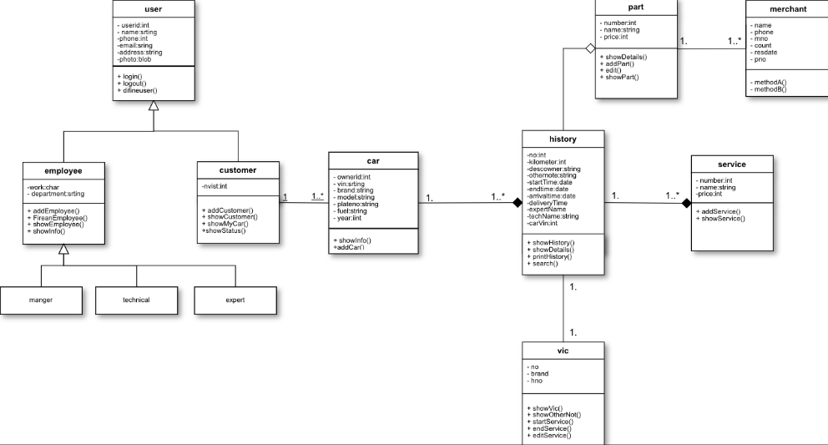

ER

